Trombone
- required for all tenor trombones – audition excerpt at 140 bpm swung
- additional requirement for lead trombone – lead trombone excerpt at 140 bpm swung
- requirement for bass trombone – bass trombone excerpt m. 32- 45 at 140 bpm swung
- optional – improvise with Bb blues backing track, for as long or short as you’d like
  - https://www.youtube.com/watch?v=5s_TP_bD-kU
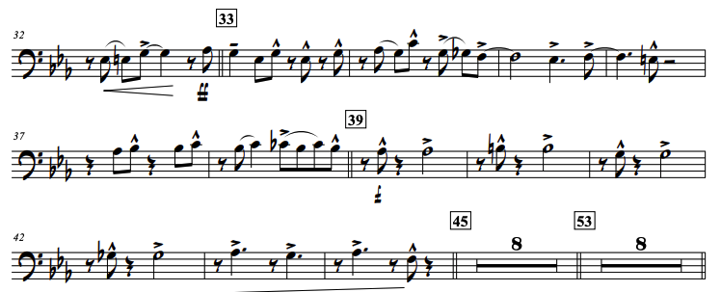
trombone excerpt
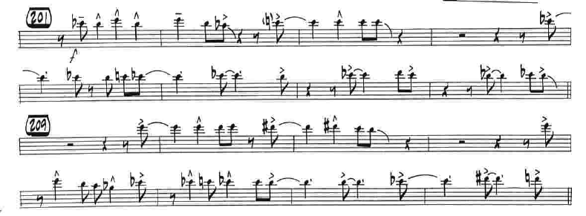
lead trombone excerpt
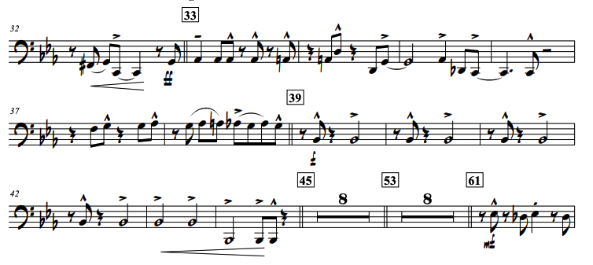
bass trombone excerpt

