Trumpet
- required for all trumpets – audition excerpt at 140 bpm swung (no repeat and ignore chord changes)
- additional requirement for lead trumpet – lead trumpet excerpt at 140 bpm swung
- optional – improvise with Bb blues backing track, for as long or short as you’d like
  - https://www.youtube.com/watch?v=5s_TP_bD-kU
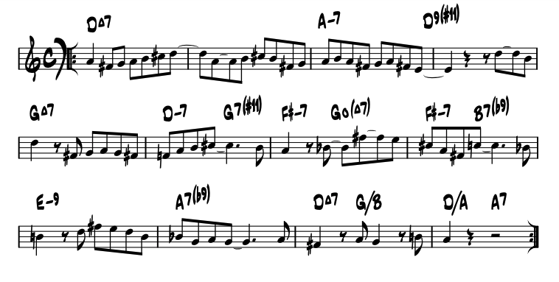

trumpet audition excerpt

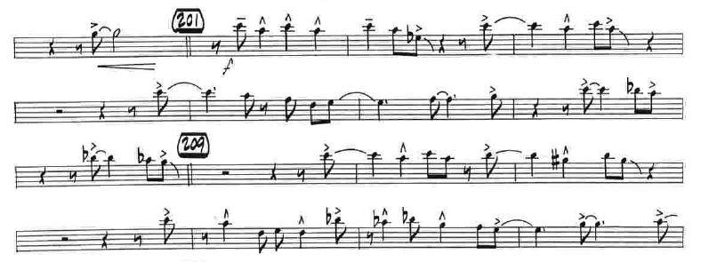

lead trumpet audition excerpt (4/4 time sig, key sig has no sharps or flats)

